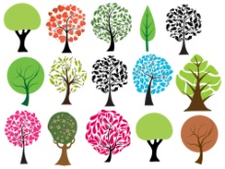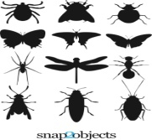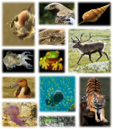

NATURE SCAVENGER HUNT
Please read the story of Creation found in Genesis 1.

Take a walk through your yard, neighborhood, park, or woods and look for as many DIFFERENT kinds of the following as you can find. Write down their names if you know them. Take pictures of the most unusual or beautiful or ugly or weird to send to Synod School, OR draw them when you get back home.

BUGS:

FLOWERS:

BIRDS:

TREES/LEAVES:

NON-HUMAN ANIMALS:

