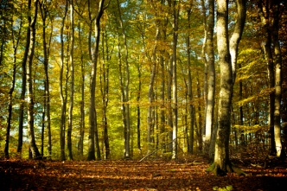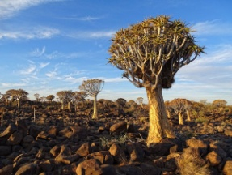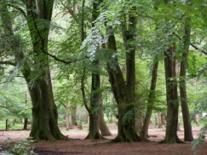

TREES SCAVENGER HUNT
Remember when you looked for different kinds of trees. Can you add to your list?
Can you think of 50 reasons we need trees? Please try.

Imagine a world with no trees. What do you think it would be like?

Imagine what the perfect tree would look like. Can you draw it or describe it?

How can we take care of trees? How can we thank God for trees?

Do you know there’s a special day called Arbor Day, when we are encouraged to plant a tree?
See if your family can plan on participating this year. You can get free trees from the Arbor Day Foundation.

Go outside and lie down under a tree. Do you see squirrels, birds, bugs or other critters living in the tree? Do you feel cooler under a tree? Give the tree a long hug. Seriously. You will receive good positive energy from it. Tell the tree how special it is. Really. How did that feel to hug and talk to a tree? Do you think it felt and heard you? Try this again and again and I bet you’ll feel really good inside.

